A PROJECT REPORT
ON

“ Smart college ”

DEVELOPED AT:



SHREE C. U. SHAH COLLEGE OF MANAGEMENT & COMPUTER EDUCATION, WADHWAN
SUBMITTED BY:

Solanki Krish K. (24CS002UG02492) Chauhan Virendra H. (24CS002UG02380)

Affiliated to: Saurashtra University

“Smart college”
Project Logo



SUBMITTED TO:

SHREE C. U. SHAH COLLEGE OF MANAGEMENT & COMPUTER EDUCATION, WADHWAN
Affiliated to: Saurashtra University
GUIDED BY: DEVELOPED BY:
Dr.Viral Dagli Solanki Krish K . (24CS002UG02492)
Chauhan Virendra H. (24CS002UG02380)

ACADEMIC YEAR: 2026-27 BCA SEM – 5

CANDIDATE’S DECLARATION
I, Solanki Krish declare that final year report entitled “smart college” is my own work conducted under the supervision of Dr.Viral Dagli the project guide of “smart college”.

I further declare that to the best of my knowledge the report for BCA 5th semester does not contain part of the work which has been submitted for the eligible for BCA degree either in this or any other university without proper citation.

Submitted To:
Dr. Viral Dagli
Department of Computer Science,
C. U. Shah College. Wadhwan City, State: Gujarat.

Solanki krish
Branch: Computer Application

CANDIDATE’S DECLARATION
I, Chauhan Virendra declare that final year report entitled “smart college” is my own work conducted under the supervision of Dr.Viral Dagli the project guide of “smart college”.

I further declare that to the best of my knowledge the report for BCA 5th semester does not contain part of the work which has been submitted for the eligible for BCA degree either in this or any other university without proper citation.

Submitted To:
Dr. Viral Dagli
Department of Computer Science,
C. U. Shah College. Wadhwan City, State: Gujarat.

Chauhan virendra
Branch: Computer Application

ACKNOWLEDGEMENT
As of now of time when we are composing this documentation we had an opportunity to look four months back when we were at this point to take up any project close by taking into consideration this cut of time and the status now, we unequivocally feel a feeling of distinction, a feeling of having developed. We consider our self-lucky to be served this excellent piece of information and experience for four valuable months we spent at Shree C. U. Shah College of Management & Computer Education, Wadhwan.

For this, we are very thankful to our college that provided their resources in making us competent and deserving of taking up such a difficult undertaking. For this undertaking project that needs an additional knowledge and guidance for the successful development, we say thanks to Dr.Viral Dagli, Department of B.C.A division.

ABSTRACT
- The Smart College is a comprehensive web-based platform developed to digitize and streamline academic administration within educational institutions. Built
using PHP and MySQL for the backend, with HTML, CSS, and JavaScript for a responsive frontend, the system replaces traditional manual record-keeping with a centralized, secure digital portal.
- The platform features a distinct, rt serves three primary user groups:

- Administrators are empowered to manage user accounts, oversee course structures, and maintain overall system data.

- Teachers are provided with dedicated tools to efficiently manage their classes, enter student marks, and upload course assignments.

- Students benefit from a personalized dashboard to access real-time academic grades, view attendance records, and download study materials.

- By integrating a secure authentication module that dynamically redirects users based on their role, the system ensures data privacy and a tailored user experience. The Smart College effectively reduces administrative workload, minimizes data redundancy, and enhances transparency and communication between all stakeholders, fostering a more organized and efficient academic environment.

INDEX

 | Cover Page | I
 | First Page | Ii
 | Candidate’s Declaration | Iii
 | College Certificate | V
 | Acknowledgement | Vii
 | Abstract | Ix
1.0 | Introduction | 1
 | 1.1 Project Details | 1
 | 1.2 Purpose | 2
 | 1.3 Scope | 2
 | 1.4 Objectives | 3
2.0 | Project Management | 4
 | 2.1 Feasibility Study | 4
 | 2.1.1 Technical Feasibility | 4
 | 2.1.2 Operational Feasibility | 4
 | 2.1.3 Economical Feasibility | 5
 | 2.2 Project Planning | 5
 | 2.2.1 Project Development Approach & Justification | 5
 | 2.3 Project Scheduling | 7
3.0 | System Requirements Study | 8
 | 3.1 Study of current system | 8
 | 3.2 Problems and weakness of current system | 9
 | 3.3 Hardware and software Requirement | 11
4.0 | Requirement of Proposed System | 12
 | 4.1 Main Modules of the System | 12
 | 4.2 Module Description | 12
 | 4.3 Features of New System | 14
5.0 | System Design | 15
 | 5.1 System architecture Design | 15
 | 5.1.1 E-R diagram | 15
 | 5.1.2 Use Case diagram | 16

    - Data Flow diagram 19
    - Activity diagram 21
  - Data Dictionary 22
  - Sample code 29
  - Screenshot 38
  - Testing 53
  - Test Cases 53
- 0 Limitations and Future Extensions 56
  - Limitations 56
  - Future Extensions 57
- 0 Conclusion and References 58
  - Conclusion 58
  - References 58

This is to certify that Mr.SOLAKI KRISH of TYBCA SEM 5 has satisfactorily completed his / her academic project work report on SMART COLLEGE as a part of course prescribed by Saurashtra University for the academic year 2026 – 27.

Enrollment No.: 24CS002UG02492

Date: 25thseptember,2026

Project Guide (Dr. Viral R. Dagli)

This is to certify that Mr.CHAUHAN VIRENDRA of TYBCA SEM 5 has satisfactorily completed his academic project work report on SMART COLLEGE as a part of course prescribed by Saurashtra University for the academic year 2026 – 27.

Enrollment No.: 24CS002UG02380

Date: 25thseptember,2026

Project Guide (Dr. Viral R. Dagli)

INTRODUCTION

1.1 PROJECT DETAILS

- The Smart College is a secure, web-based platform designed to digitize and streamline academic administration for educational institutions. It acts as a digital bridge that connects students and administrators on a single platform, ensuring speed, transparency, and complete control over academic workflows. The system aims to replace slow, traditional paper-based record-keeping with a reliable, fast, and user-friendly digital environment.
- On the student side, the platform provides a smooth and simple experience where students can easily register, create secure accounts, build personal profiles, and access their academic information. Students can view real-time grades, check attendance records, download study materials, and track their academic progress in real-time. This gives students a clean, organized, and hassle-free way to manage their academic journey from anywhere.
- On the administrator side, the admin has complete control over the entire system. Through the dedicated admin dashboard, administrators can manage student accounts, oversee course structures, add or remove courses, manage departments, and maintain overall system data. They can also generate reports and ensure smooth operation of the entire platform.
- By integrating secure authentication and role-based access, the Smart College Management System creates a scalable, secure, and user-friendly environment that simplifies academic management for both students and administrators.

PURPOSE

- The main purpose of the Smart College is to digitize and simplify the academic management process for educational institutions. The system is designed to eliminate manual paperwork and provide a centralized platform where students and administrators can efficiently manage academic activities.
- For students, the purpose is to provide easy access to their academic information, including grades, attendance records, and study materials, all from a single dashboard. This helps students track their progress and stay updated without relying on physical notice boards or manual inquiries.
- For administrators, the purpose is to streamline user management, course management, and overall system administration. The system enables admins to easily manage student accounts, oversee courses, generate reports, and maintain organized digital records.
- Overall, the purpose of the Smart College is to create a secure, efficient, and user-friendly environment that improves communication, reduces administrative workload, and enhances the overall academic experience for both students and administrators

SCOPE
- The scope of the Smart College is to provide a complete digital solution for academic management. The system focuses on students and administrators as the primary users.
- The project includes student registration, profile management, a dashboard for viewing grades and attendance, and downloading study materials. For administrators, the system includes managing student accounts, courses, departments, and generating reports. Secure login and role-based authentication are also covered.
- The system does not include online examinations, fee payment, library management, hostel management, mobile application, or real-time notifications. It is limited to web-based academic management only.

OBJECTIVES
- The primary objective of the Smart College Management System is to develop a centralized digital platform that simplifies academic management for both students and administrators.
- The system aims to provide students with easy online access to their academic records, including grades, attendance, and study materials, while enabling administrators to efficiently manage student accounts, courses, and departments.
- Another key objective is to reduce manual paperwork and administrative workload by automating routine tasks.
- The system also focuses on ensuring data security through role-based authentication and improving transparency and communication between students and the administration.
- Additionally, the system aims to generate accurate reports for academic monitoring and decision-making, while remaining user-friendly and scalable for future enhancements.

PROJECT MANAGEMENT

FEASIBILITY STUDY:
    - Technical Feasibility:The project is highly feasible from a technical perspective as it is built on the stable and widely supported Apache, PHP, and MySQL stack, making it fully compatible with local environments like WAMP or XAMPP. The backend architecture utilizes modular PHP scripts that leverage PHP Data Objects (PDO) to interface with the MySQL database, ensuring that all queries are parameterized to prevent SQL injection vulnerabilities. Security is robustly enforced using PHP’s native session handling for Role-Based Access Control (RBAC), which restricts directory access based on user privileges, and encrypts all user credentials using the bcrypt hashing algorithm. The database schema is cleanly normalized with relational keys linking user accounts, students, courses, attendance, and marks, allowing for efficient data retrieval. On the frontend, the system relies on standard HTML5, CSS3 styling, and Bootstrap Icons to build a responsive, lightweight user interface that loads quickly and is easy to maintain without the overhead of heavy third-party JavaScript frameworks.

    - Operational Feasibility:The operational feasibility of the system is exceptionally strong because it simplifies day-to-day college administration by replacing manual, paper-based tracking with a centralized digital portal. The user interface features an intuitive, web-based layout that requires no prior technical training for students to log in and review their academic details, such as grade sheets, attendance summaries, and daily notices. By consolidating all administrative rights under the Admin role, the system establishes a single point of data entry, which minimizes errors and ensures that course registrations, student records, marks, and attendance updates are managed consistently. The student portal operates on a secure, read-only basis for critical academic records, enabling students to independently monitor their progress and immediately view administrator-posted announcements, which significantly reduces the workload on administrative staff who would otherwise spend time answering manual student inquiries.

    - Economical Feasibility: The system is highly feasible economically as it is developed and deployed using entirely open-source, free technologies, including Apache, PHP, MySQL, and Bootstrap, which eliminates any software licensing or subscription fees. The application can run on existing hardware and standard local hosting environments like WAMP, meaning there are no additional hardware acquisition costs required for deployment. From an operational perspective, the system delivers a strong return on investment by digitalize student records, academic marks, and attendance tracking, which significantly reduces expenses associated with paper, printing, and physical notice storage. Furthermore, by automating record retrieval and consolidating administrative management, the college minimizes manual labor hours and operational errors, making the system an extremely cost-effective solution with negligible ongoing maintenance costs

PROJECT PLANNING:

Project Development Approach & Justification:

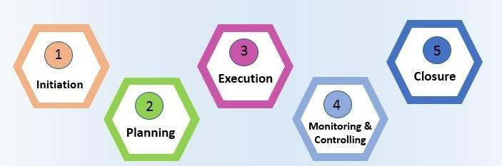

How use this model for developing this project
  - In the initiation phase, you will define the project. You will sort out the project goals, scope, and resources of the project and what roles are needed on the team. Clarifying what stakeholders expect out of the project, and what exactly the project is aiming to achieve (and why) will give the project and team clear direction.

  - In the planning phase, you will determine the steps to actually achieve the project goals—the “how” of completing a project. You will establish budgets, timelines, milestones, source materials, and necessary documents. This step also involves calculating and predicting risk, establishing change processes in place, and outlining communication protocols. If the initiation phase is assembling your troops, the planning phase is deciding what to do with them.
- Executing a project means putting your plan into action and keeping the team on track. Generally, this means tracking and measuring progress, managing quality, mitigating risk, managing the budget, and using data to inform your decisions. Specific steps might include:
  - Using tools like DFD and E-R or burn down charts to track progress on tasks
  - Responding to risks when they manifest
  - Recording costs
  - Keeping team members motivated and on task
  - Keeping stakeholders informed of progress
  - Incorporating changes via change requests
- In the closing phase of the project management life-cycle, you will conclude project activities, turn the finished product or service over to its new owners and assess the things that went well and did not go so well. It will also be a time to celebrate your hard work. Steps in the closing phase can include:
  - Conducting retrospectives and take notes of changes you can implement in the future.
  - Communicating to stakeholders at the end of the project and providing an impact report
  - Communicating with the new owners of a project.
  - Creating a project closeout report
  - Celebrating the end of the project and your successes

2.2 PROJECT SCHEDULING:
Scheduling in project management is the listing of activities, deliverable, and milestones within a project. A schedule usually includes a planned start and finish date, duration, and resources assigned to each activity. Effective project scheduling is a critical component of successful time management, especially for professional service businesses.

In this guide, we will explore the concept of scheduling in project management, its importance, and how it is done. We will also look into the different scheduling techniques, tools, and best practices that project managers can leverage to keep their projects on track and deliver successful outcomes.
If you are looking for a tool that will allow you to have full control over the scheduling processes for your projects, Wrike has the right solution for you. You can start today and unlock the full power of project management.
Resources required for Development of Project:
- Human effort
- Sufficient disk space on server
- Specialized hardware
- Software technology
- Travel allowance required by project staff, etc.

Advantages of Project Scheduling:
- It simply ensures that everyone remains on same page as far as tasks get completed, dependencies, and deadlines.
- It helps in identifying issues early and concerns such as lack or unavailability of resources.
- It also helps to identify relationships and to monitor process.
- It provides effective budget management and risk mitigation.

SYSTEM REQUIREMENT STUDY

STUDY OF CURRENT SYSTEM
- The current system relies on manual registers and fragmented spreadsheets to manage student data, which causes administrative delays and limits data sharing. The primary weakness of this approach is data redundancy, as student information is often duplicated across different department files. Manual calculations of grades and attendance are highly prone to human error and consume significant staff time at the end of each term. Security is also a major concern, as spreadsheets lack encrypted access controls, exposing sensitive student records to unauthorized modifications. Additionally, because there is no digital portal, students must make manual inquiries to check their records, causing unnecessary administrative bottlenecks.

Limitations of the Current System:-

- The limitations of the current system stem primarily from its reliance on physical documents and local, non-networked spreadsheets. Data retrieval is slow and inefficient, as retrieving a single student's historical attendance or academic record requires administrative staff to manually search through physical filing cabinets or multiple spreadsheet versions. The lack of centralized data validation leads to frequent data entry errors and inconsistencies across different departmental records. Security is highly restricted, as physical documents can be misplaced, damaged by environmental factors, or accessed by unauthorized individuals, while basic spreadsheets lack role-based permissions to prevent tampering. Additionally, the lack of real-time communication channels means that critical updates and announcements cannot be instantly broadcast, resulting in communication gaps between the administration and the student body.

Need for Improvement

- There is a critical need for improvement to transition the institution from a slow, paper-based workflow to an agile, digital environment. Implementing a centralized database system is essential to eliminate data duplication, ensure data integrity, and protect student

records with robust security protocols and access controls. Automating the processes of tracking attendance and calculating academic grades will eliminate manual calculation errors and significantly reduce the time administrative staff spend compiling reports. Furthermore, establishing a digital portal will provide students with instant, self-service access to their academic progress and notices, reducing administrative workloads and enhancing overall institutional transparency and efficiency.

PROBLEMS AND WEAKNESS OF CURRENT SYSTEM

Problems:
- Delayed Access to Academic Records: Students have no self-service portal to view their grades, marks, or attendance history, which forces them to make frequent, time-consuming visits to the administration office, creating long queues and administrative delays.
- Frequent Calculation and Entry Errors: Recording daily attendance and computing semester-end grade averages manually on paper registers or standard spreadsheets is highly prone to human error, leading to incorrect records and disputes.
- Inefficient Notice and Information Distribution: Relying on physical bulletin boards, classroom announcements, or verbal communication means that critical updates, exam schedules, and holiday notices often fail to reach all students in a timely manner.
- Data Duplication and Inconsistency: Student enrollment details and course information are manually copied across different department sheets, creating data inconsistencies where a student's record might be updated in one place but remain outdated in another.
- Slow Retrieval of Archives: Searching for historical data, such as a student's past semester attendance or enrollment history, requires staff to manually sift through stacks of registers or scattered local computer folders.

Weaknesses of Current System
- Lack of Centralization: The current setup operates in isolated silos with no unified relational database, meaning there is no synchronization between user login accounts, student profiles, courses, and marks tables.
- Absent Role-Based Security Controls: The system lacks structured login permissions and encryption, meaning sensitive records are accessible to anyone with access to the physical office or local computers, leaving data open to unauthorized modification.
- Vulnerability to Data Loss and Damage: Paper records are highly vulnerable to physical deterioration, fire, water damage, or misplacement, and local digital spreadsheets lack automatic backup mechanisms, meaning any system crash can lead to permanent data loss.
- Complete Dependency on Manual Processing: Every operation—from enrolling a student to logging attendance and publishing grades—requires active, manual human intervention, leaving the institution with zero automation and high operational overhead.
- Lack of Audit Trails: Because there is no logging mechanism in manual registers or simple Excel files, there is no way to track who created, modified, or deleted a particular student's record, making it difficult to maintain accountability.

3.3 HARDWARE AND SOFTWARE REQUIREMENTS:

Hardware Requirements (Minimum):

Component | Specification
Processor | Intel Core 2 Duo
RAM | 4 GB RAM
Hard Disk | 500 GB

Software Requirements

Operating System: Windows 7, Windows 8.1, etc…

Front End Tools: PHP

Back End Tools: MySQL

Office Automation Tools:
- Microsoft Office Word
- Microsoft Visio

REQUIREMENT OF PROPOSED SYSTEM

MAIN MODULES OF THE SYSTEM:
There are basically three main modules in the systems.
    - Admin User
    - Registered User
    - Visitor User

MODULE DESCRIPTION:
There are four modules in this system.
- Admin User:The Admin User module is the central administrative hub of the system, giving the administrator full access to manage and maintain the system's databases. The key functions within this module include
- Student Account Management: The admin can register new students, generate secure login credentials, update personal details, and delete student records when they leave the institution.
- Course Management: This feature allows the admin to define the academic curriculum by adding new courses, assigning course codes, and updating or removing course descriptions.
- Course Management: This feature allows the admin to define the academic curriculum by adding new courses, assigning course codes, and updating or removing course descriptions.
- Academic Records Entry: Since the teacher role is excluded, the admin is responsible for directly entering, modifying, and managing student marks for exams, as well as logging daily attendance records.
- Notice Board Administration: The admin can create, publish, and delete announcements on the notice board, with the ability to target notices to all users or specific student groups.
- System Oversight: The admin has the authority to monitor system usage, reset passwords, and maintain the database to ensure data integrity and system security.

- Registered User :The Registered User module defines the interface, features, and permissions available to students who have successfully created an account. Once registered and logged in, a student can access the portal to view their profiles and track their academic records

- Self-Registration: Allows students to create their own accounts by providing personal details (first name, last name, email, and phone number) and setting up a secure username and password.
- Profile Viewer: Provides students with a read-only profile dashboard showing their personal details, unique student ID, registered email address, phone number, and enrollment date.
- Performance Monitoring (Marks): Students can access a dedicated grades section to view their marks for exams, continuous assessments, and final grades across their enrolled courses.
- Attendance Tracking: Students can view their attendance logs, monitoring their total present, absent, or late days to ensure they meet the minimum attendance requirements.
- Announcements Viewer: Students have real-time access to the college notice board, where they can view notices and critical dates posted by the administrator.

- Visitor:The Visitor module defines the experience and options available to users who have not yet logged into the system (guests). This interface is public-facing and provides access to entry-level registration and login portals

- Landing Page Interaction: Visitors can view the public home page, which displays a welcome message and introduces the main features of the portal.
- System Navigation: Visitors can navigate easily between the public sections of the application, including the home page, login screen, and registration page.
- Portal Login Access: Provides visitors with a secure form to input their username and password, which validates credentials against the database and redirects them to their respective dashboards.

- Student Self-Registration: Allows visitors to access the registration form to create a new student account, after which they are designated as a "Registered User" in the system database.

  - FEATURES OF NEW SYSTEM:The proposed smart College introduces several modern capabilities designed to automate record-keeping and improve communication. The key features of the new system include
- Centralized Relational Database: All student information, course curriculum, attendance, and exam grades are stored in a single, unified database, ensuring data consistency and eliminating record duplication.
- Secure Authentication & Session Management: Secure login capabilities are implemented using bcrypt password hashing and role-based access control, protecting sensitive academic data from unauthorized users.
- Comprehensive Admin Dashboard: Provides the administrator with complete control over the system, enabling them to easily register students, configure course details, input grades, and log attendance through simple web forms.
- Self-Service Student Portal: Registered students gain direct, real-time access to their academic records, including exam marks, attendance status, and profile information, without needing to contact office staff.
- Real-Time notice Board: Admins can publish critical updates, announcements, and schedules directly to the notice board, where they are immediately displayed on the students' homepages.
- Graphical Data Analytics: Incorporates interactive charts (such as donut and bar charts) on the student dashboard, allowing students to visualize their attendance ratios and exam grades dynamically.

SYSTEM DESIGN

SYSTEM ARCHITECTURE DESIGN:

ERDiagram :

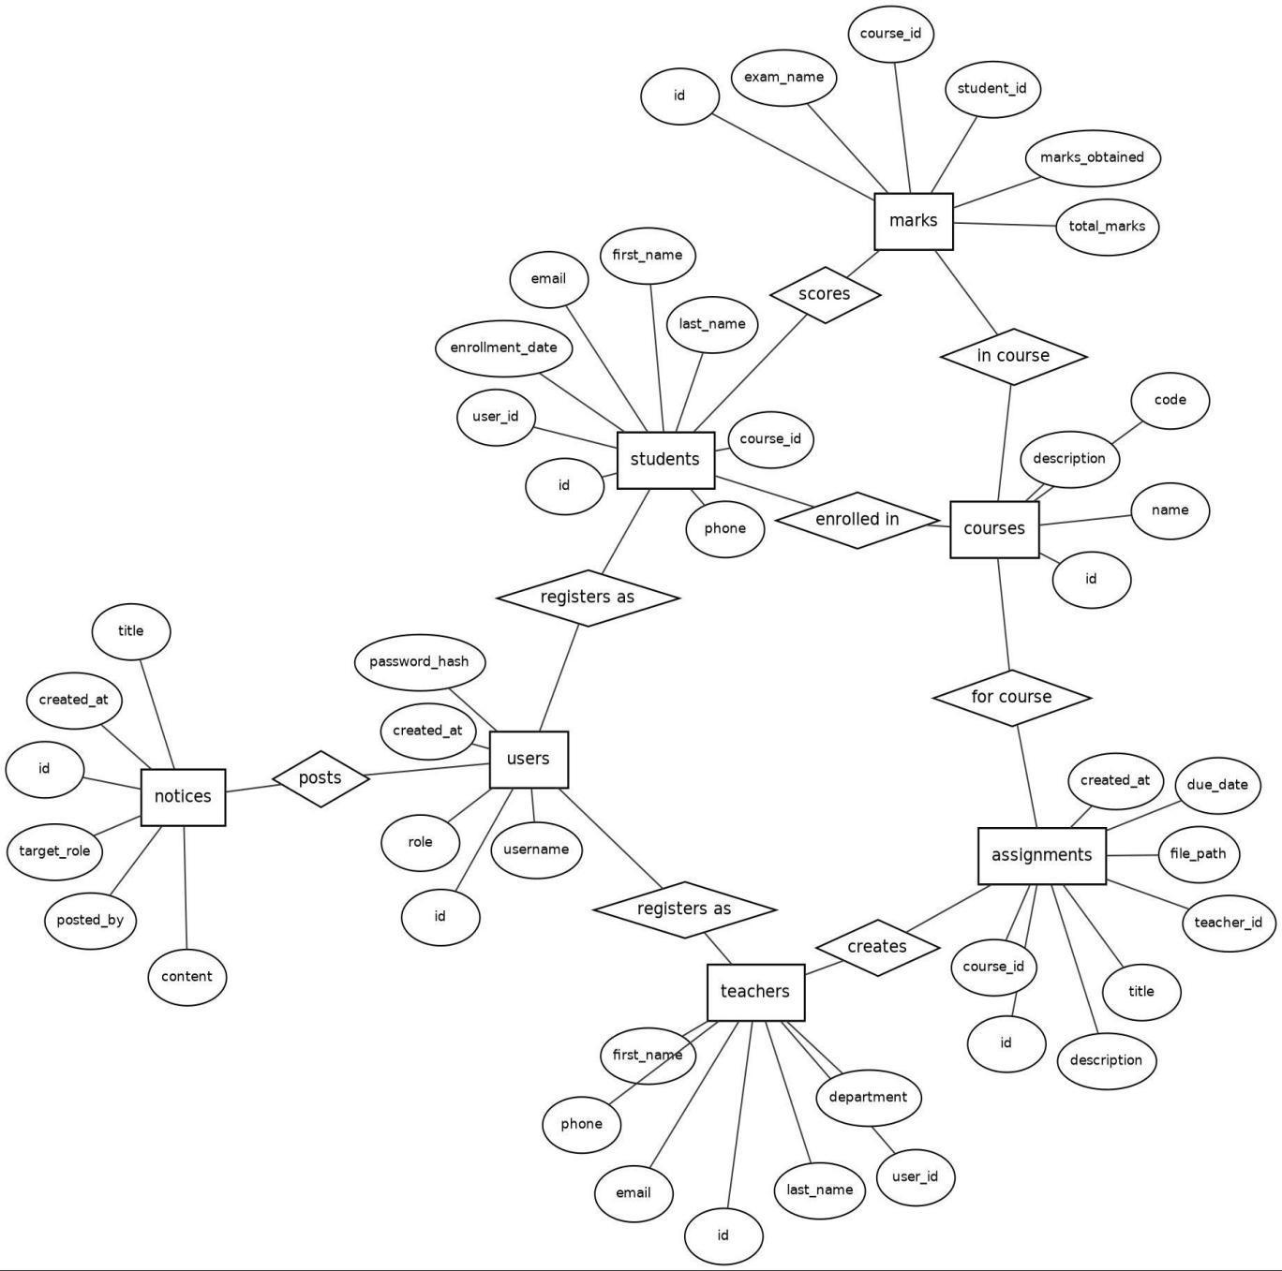

Figure 5.1: E – R Diagram

Use case Diagram:

Admin


College Management (Admin Module)
Login
Manage Students
Manage Teachers
Manage Courses
Manage Notices
Administrator
View Dashboard
Logout

Figure 5.2: Use case Diagram for Admin

Register:
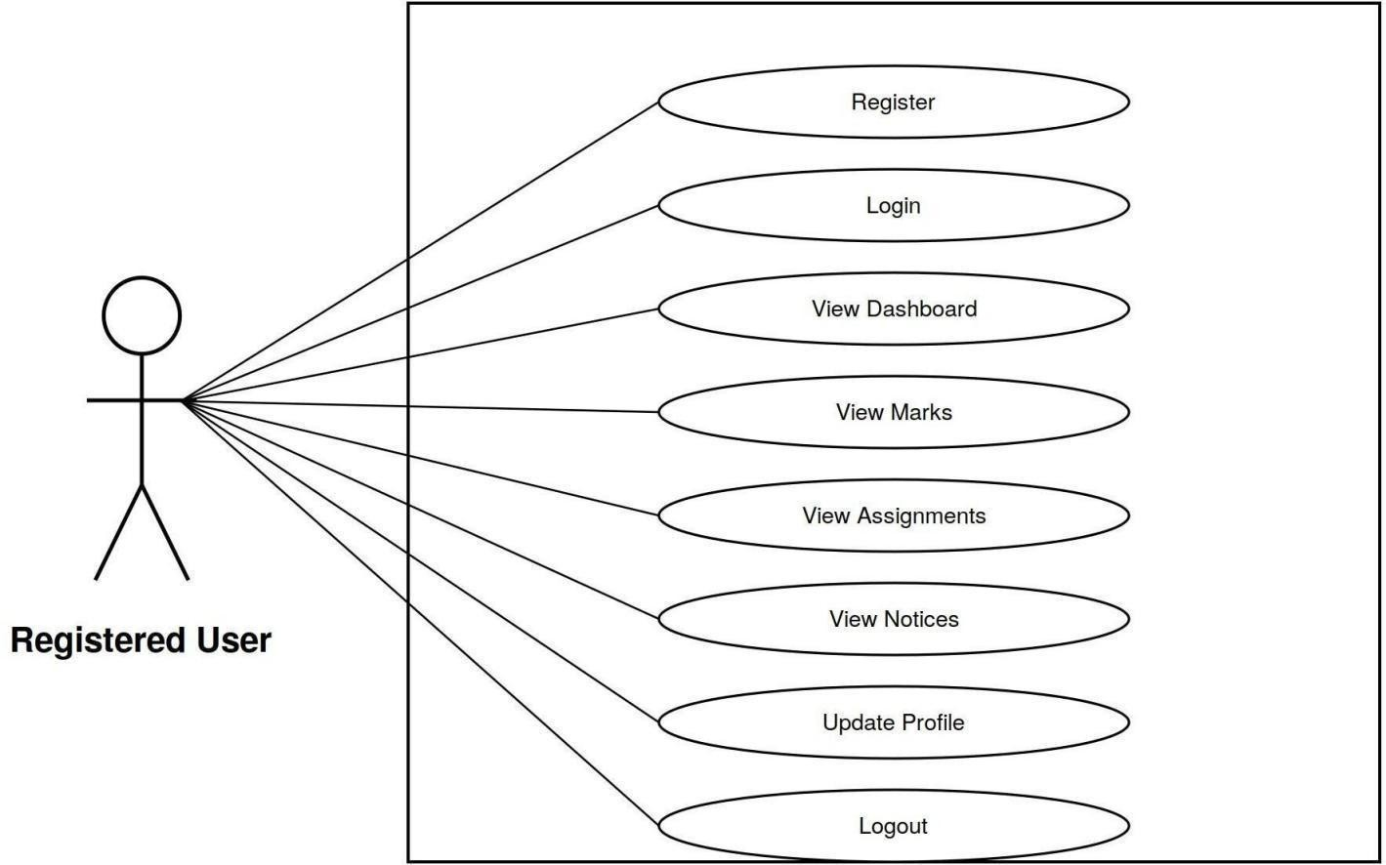

Figure 5.3: Use case Diagram for Register

Visitor :
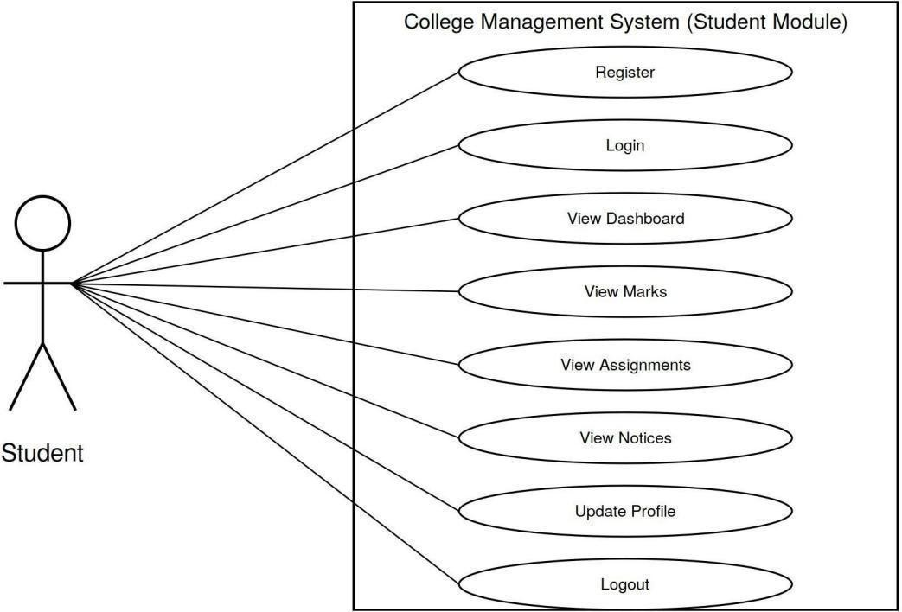

Figure 5.4: Use case Diagram for Visitor

Data Flow Diagram:

Contex Diagram :

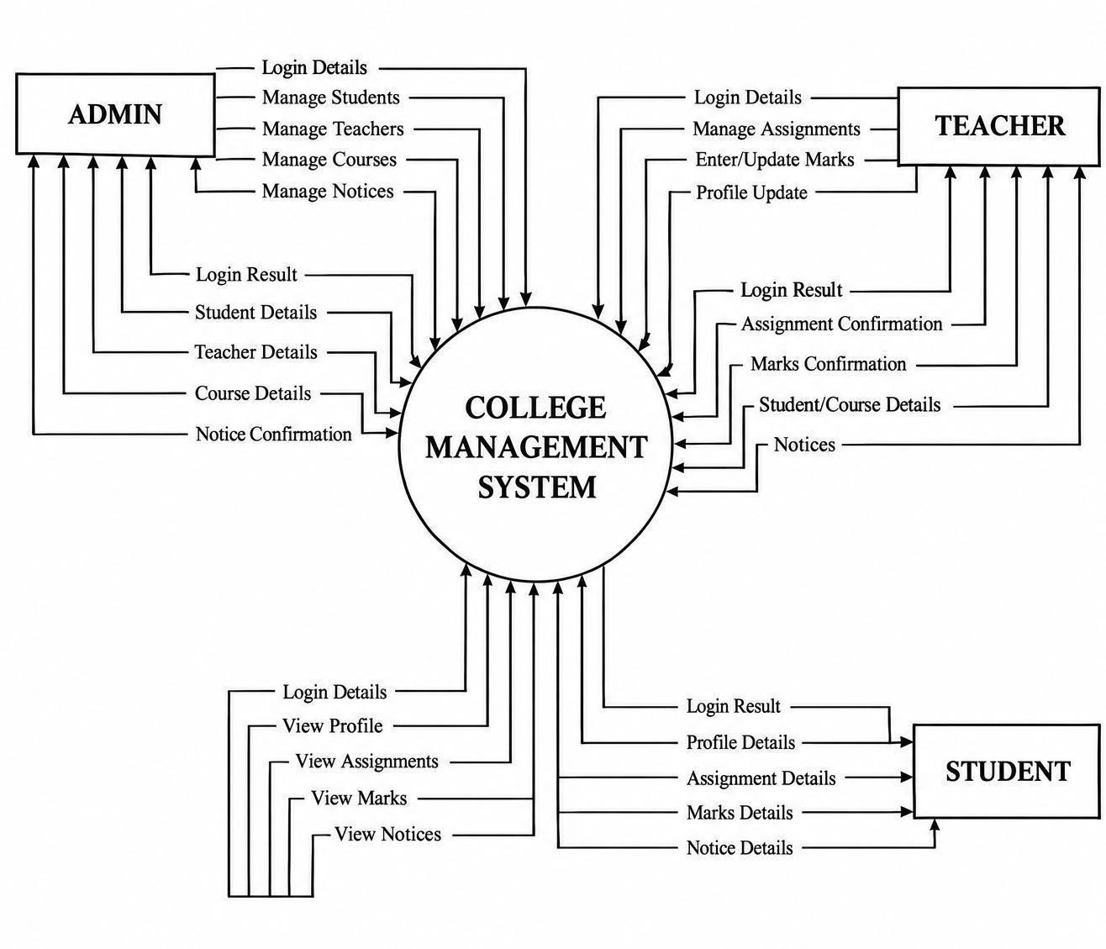

Figure 5.6: Context Diagram

Level 1 Data Flow Diagram :

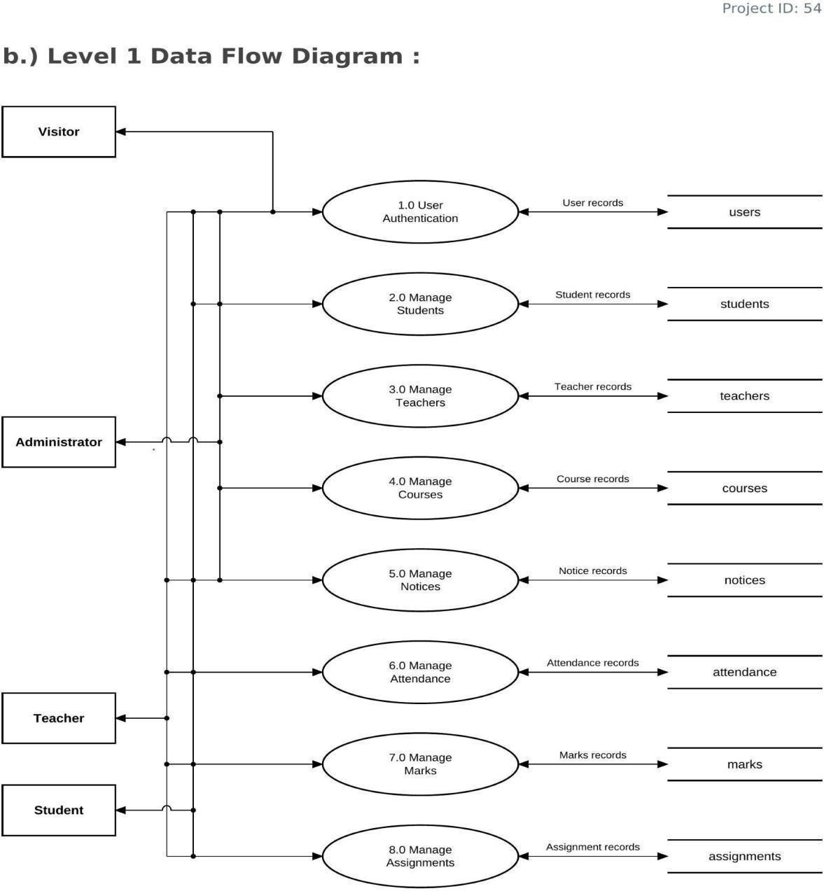

Figure 5.6: 1 - Level Data Flow Diagram

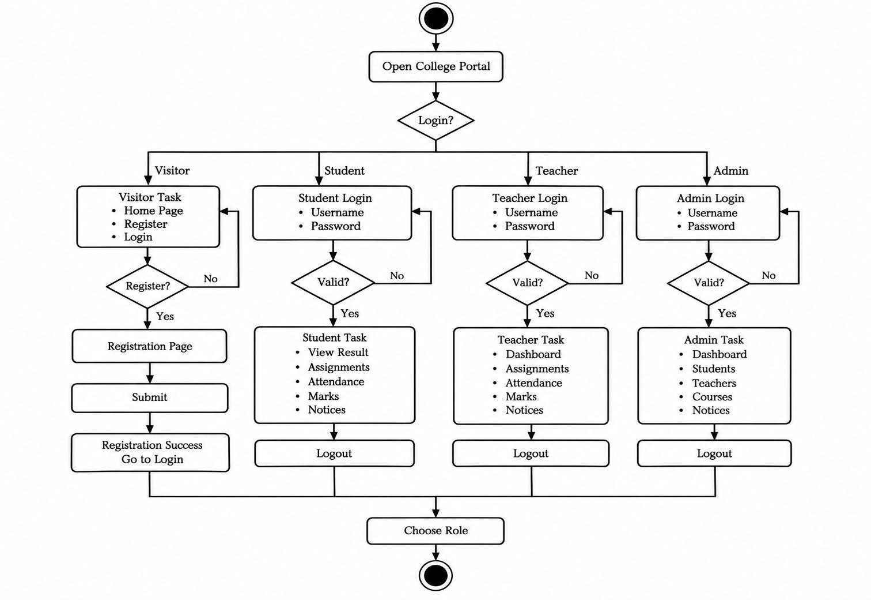
Activity Diagram :

Figure 5.7: Activity Diagram

DATA DICTIONARY
Table Name: users
Description: Stores login credentials, account roles, and metadata for all system users.

SR. No | FIELD NAME | DATA TYPE | SIZE | CONSTRAINT | DESCRIPTION
1 | id | Int | - | Primarykey, Auto increment | UniqueIDof the user
2 | username | Varchar | 50 | Not null, Unique | Usernameusedfor login
3 | password_hash | Varchar | 255 | Not null | Hashed/secure password
4 | role | Enum | - | Not null | Access control role ('admin', 'teacher', 'student')
5 | created_at | Timestamp | - | Default CURRENT_TIMESTA MP | Timeofaccount creation

Table Name: course
Description: Storesdetails of academic courses available in the system.

SR. No | FIELD NAME | DATA TYPE | SIZE | CONSTRAINT | DESCRIPTION
1 | id | Int | - | Primarykey, Auto increment | UniqueIDof the course
2 | code | Varchar | 20 | Not null, Unique | Unique code of the course (e.g. CS101)
3 | name | Varchar | 100 | Not null | Fulltitleof the course
4 | description | Text | - | Null | Briefdetailsabout the course

Table Name: student
Description: Stores profile details for students enrolled in courses.

SR. No | FIELD NAME | DATA TYPE | SIZE | CONSTRAINT | DESCRIPTION
1 | id | Int | - | Primarykey, Auto increment | UniqueIDof the student
2 | user_id | Int | - | Foreign key (users.id) | Linkstothelogin account
3 | first_name | Varchar | 50 | Not null | Firstnameofthe student
4 | last_name | Varchar | 50 | Not null | Lastname ofthe student
5 | email | Varchar | 100 | Not null, Unique | Email of the student
6 | phone | Varchar | 20 | Null | Contactnumberof the student
7 | course_id | Int | - | Foreignkey (courses.id) | Course enrolled in (Set Null on Delete)

Table Name: teachers
Description: Stores profile details for teachers and faculty.

SR. No | FIELD NAME | DATA TYPE | SIZE | CONSTRAINT | DESCRIPTION
1 | id | Int | - | Primarykey, Auto increment | UniqueIDof the teacher
2 | user_id | Int | - | Foreign key (users.id) | Linkstothelogin account
3 | first_name | Varchar | 50 | Not null | Firstnameofthe teacher
4 | last_name | Varchar | 50 | Not null | Lastname ofthe teacher
5 | email | Varchar | 100 | Not null, Unique | Email of the teacher
6 | phone | Varchar | 20 | Null | Contactnumberof the teacher
7 | department | Varchar | 100 | Null | Departmentname (e.g., Science)

Table Name: marks
Description: Records marks obtained by students in exams.

SR. No | FIELD NAME | DATA TYPE | SIZE | CONSTRAINT | DESCRIPTION
1 | id | Int | - | Primarykey, Auto increment | UniqueIDof the marks record
2 | student_id | Int | - | Foreign key (students.id) | Studentwhotook the exam
3 | course_id | Int | - | Foreignkey (courses.id) | Coursetheexam belongs to
4 | exam_name | Varchar | 100 | Not null | Nameof theexam (e.g., Midterm)
5 | marks_obtained | Decimal | 5,2 | Not null | Marksscoredby the student
6 | total_marks | Decimal | 5,2 | Not null | Maximum possible marks for the exam

Table Name: assignments
Description: Stores assignments uploaded/created by teachers.

SR. No | FIELD NAME | DATA TYPE | SIZE | CONSTRAINT | DESCRIPTION
1 | id | Int | - | Primarykey, Auto increment | UniqueIDof the assignment
2 | title | Varchar | 100 | Not null | Title of the assignment
3 | description | Text | - | Null | Assignment tasks/details
4 | file_path | Varchar | 255 | Null | Server location of theassignment file
5 | teacher_id | Int | - | Foreignkey (teachers.id) | Instructorwho assigned it
6 | course_id | Int | - | Foreignkey (courses.id) | Course the assignment belongs to
7 | due_date | Date | - | Not null | Submissiondeadline date
8 | created_at | Timestamp | - | Default CURRENT_TIMESTA MP | Assignmentposting timestamp

Table Name: notice
Description: Stores announcements and bulletins posted to the portal.

SR. No | FIELD NAME | DATA TYPE | SIZE | CONSTRAINT | DESCRIPTION
1 | id | Int | - | Primarykey, Auto increment | UniqueIDof the notice
2 | title | Varchar | 100 | Not null | Title of the notice
3 | content | Text | - | Not null | Content/bodyof notice
4 | posted_by | Int | - | Foreign key (users.id) | Admin/Userwho posted the notice
5 | target_role | Enum | - | Default 'all' | Targetaudience ('all', 'student', 'teacher')
6 | created_at | Timestamp | - | Default CURRENT_TIMESTA MP | Postingtimestampof notice

Sample code:
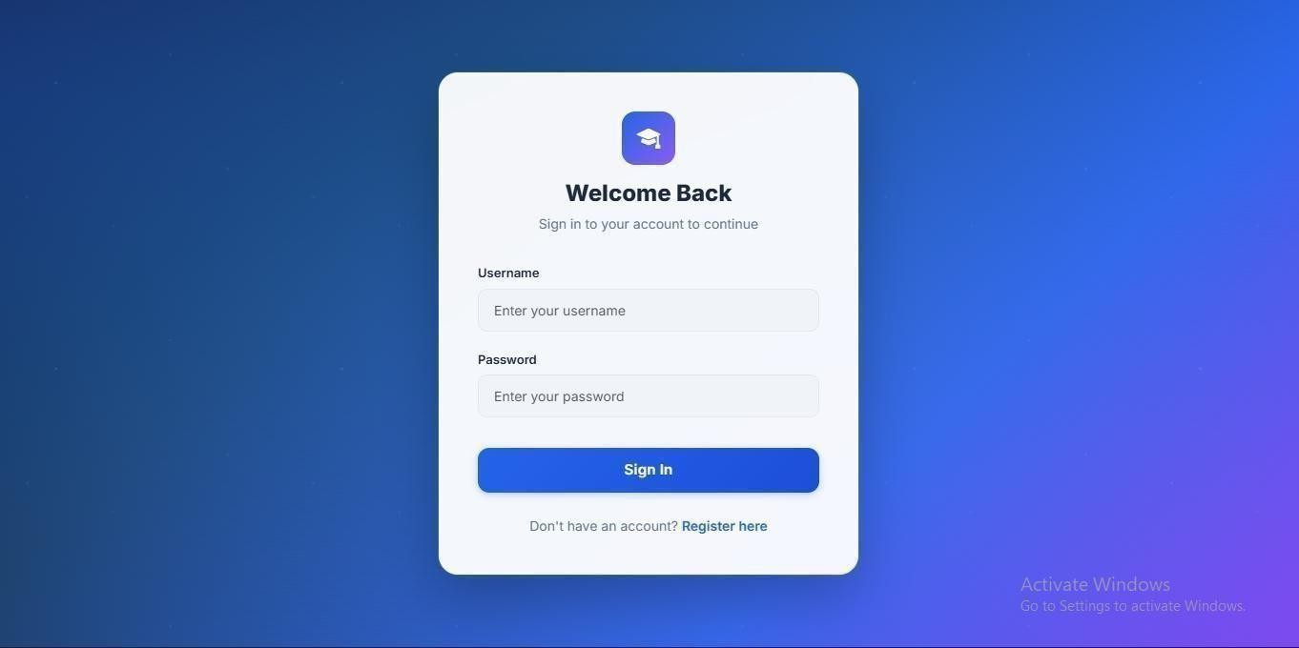
Login Design:

<?php
require_once 'includes/db.php'; require_once'includes/auth.php'; redirectBasedOnRole();
$error = '';

if ($_SERVER['REQUEST_METHOD'] === 'POST') {

$username = trim($_POST['username']);
$password = $_POST['password'];

if (empty($username) || empty($password)) {
$error = 'Please enter both username and password.';
} else {
$stmt = $pdo->prepare("SELECT id, username, password_hash, role FROM users WHERE username = ?");
$stmt->execute([$username]);
$user = $stmt->fetch();

if ($user && password_verify($password, $user['password_hash']))
{ if ($user['role'] === 'teacher') {
$error = 'Teacher login is disabled.';
} else {
$_SESSION['user_id'] = $user['id'];
$_SESSION['username'] = $user['username'];
$_SESSION['role'] = $user['role'];

// Redirect based on role redirectBasedOnRole();
}
} else {

$error = 'Invalid username or password.';
}
}
}

require_once 'includes/header.php';
?>

<div class="auth-wrapper">
<div class="auth-card">
<div class="text-center mb-4">
<div style="width: 56px; height: 56px; background: linear-gradient(135deg, var(--primary), var(--purple)); border-radius: 14px; display: flex; align-items: center; justify-content: center; margin: 0 auto 16px; color: #fff; font-size: 24px;">
<i class="bi bi-mortarboard-fill"></i>
</div>
<h2>Welcome Back</h2>
<p class="subtitle">Sign in to your account to continue</p>
</div>

<?php if ($error): ?>
<div class="alert alert-danger" role="alert">
<i class="bi bi-exclamation-circle me-2"></i><?php echo htmlspecialchars($error); ?>

</div>
<?php endif; ?>

<form method="POST" action="login.php">
<div class="mb-3">
<label for="username" class="form-label">Username</label>
<input type="text" class="form-control" id="username" name="username" placeholder="Enter your username" required>
</div>
<div class="mb-4">
<label for="password" class="form-label">Password</label>
<input type="password" class="form-control" id="password" name="password" placeholder="Enter your password" required>
</div>
<button type="submit" class="btn btn-primary">Sign In</button>
</form>

<div class="auth-footer">
Don't have an account? <a href="register.php">Register here</a>
</div>
</div>
</div>

<?php require_once 'includes/footer.php'; ?

Registeration Design:

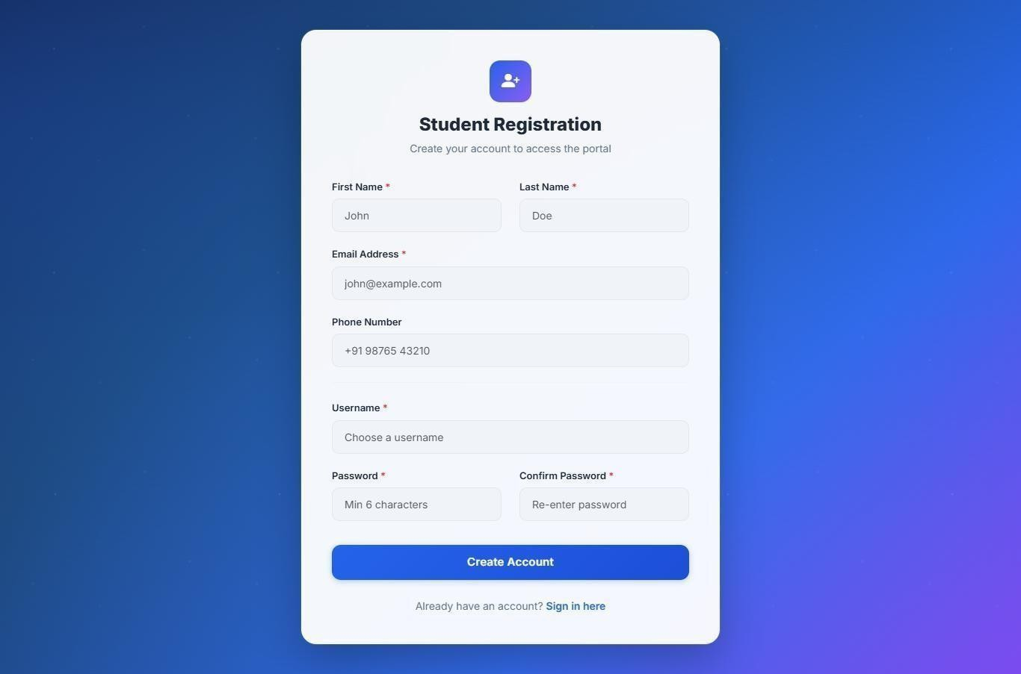

<?php
require_once 'includes/db.php'; require_once 'includes/auth.php';
redirectBasedOnRole();
$error = '';
$success = '';
if ($_SERVER['REQUEST_METHOD'] === 'POST') {
$username = trim($_POST['username']);

$password = $_POST['password'];
$confirm_password = $_POST['confirm_password'];
$first_name = trim($_POST['first_name']);
$last_name = trim($_POST['last_name']);
$email = trim($_POST['email']);
$phone = trim($_POST['phone']);
if (empty($username) || empty($password) || empty($first_name) || empty($last_name) || empty($email)) {
$error = 'Please fill in all required fields.';
} elseif ($password !== $confirm_password) {
$error = 'Passwords do not match.';
} else {
// Check if username or email exists
$stmt = $pdo->prepare("SELECT id FROM users WHERE username = ?");
$stmt->execute([$username]); if ($stmt->fetch()) {
$error = 'Username is already taken.';
} else {
$stmt = $pdo->prepare("SELECT id FROM students WHERE email = ?");
$stmt->execute([$email]); if ($stmt->fetch()) {
$error = 'Email is already registered.';
} else {
try {
$pdo->beginTransaction();
// Insert user
$password_hash = password_hash($password, PASSWORD_DEFAULT);
$stmt = $pdo->prepare("INSERT INTO users (username, password_hash, role) VALUES (?, ?, 'student')");
$stmt->execute([$username, $password_hash]);
$user_id = $pdo->lastInsertId();
// Insert student profile
$stmt = $pdo->prepare("INSERT INTO students (user_id, first_name, last_name, email, phone, enrollment_date) VALUES (?, ?, ?, ?, ?, CURDATE())");
$stmt->execute([$user_id, $first_name, $last_name, $email, $phone]);

$pdo->commit();
$success = 'Registration successful! You can now login.';

} catch (Exception $e) {
$pdo->rollBack();
$error = 'Registration failed. Please try again.';
}
}
}
}
}
require_once 'includes/header.php';
?>
<div class="auth-wrapper">
<div class="auth-card wide">
<div class="text-center mb-4">
<div style="width: 56px; height: 56px; background: linear-gradient(135deg, var(--primary), var(--purple)); border-radius: 14px; display: flex; align-items: center; justify-content: center; margin: 0 auto 16px; color: #fff; font-size: 24px;">
<i class="bi bi-person-plus-fill"></i>
</div>
<h2>Student Registration</h2>
<p class="subtitle">Create your account to access the portal</p>
</div>
<?php if ($error): ?>
<div class="alert alert-danger" role="alert">
<i class="bi bi-exclamation-circle me-2"></i><?php echo htmlspecialchars($error); ?>
</div>
<?php endif; ?>
<?php if ($success): ?>
<div class="alert alert-success" role="alert">
<i class="bi bi-check-circle me-2"></i><?php echo htmlspecialchars($success); ?>
</div>
<div class="text-center mt-3 mb-2">
<a href="login.php" class="btn btn-primary" style="max-width: 200px;">Go to Login</a>
</div>
<?php else: ?>
<form method="POST" action="register.php">

<div class="row">
<div class="col-md-6 mb-3">
<label for="first_name" class="form-label">First Name <span class="text-danger">*</span></label>
<input type="text" class="form-control" id="first_name" name="first_name" placeholder="John" required>
</div>
<div class="col-md-6 mb-3">
<label for="last_name" class="form-label">Last Name <span class="text-danger">*</span></label>
<input type="text" class="form-control" id="last_name" name="last_name" placeholder="Doe" required>
</div>
</div>
<div class="mb-3">
<label for="email" class="form-label">Email Address <span class="text-danger">*</span></label>
<input type="email" class="form-control" id="email" name="email" placeholder="john@example.com" required>
</div>
<div class="mb-3">
<label for="phone" class="form-label">Phone Number</label>
<input type="text" class="form-control" id="phone" name="phone" placeholder="+91 98765 43210">
</div>
<hr style="border-color: var(--border-color); margin: 20px 0;">
<div class="mb-3">
<label for="username" class="form-label">Username <span class="text-danger">*</span></label>
<input type="text" class="form-control" id="username" name="username" placeholder="Choose a username" required>
</div>
<div class="row">
<div class="col-md-6 mb-3">
<label for="password" class="form-label">Password <span class="text-danger">*</span></label>
<input type="password" class="form-control" id="password" name="password" placeholder="Min 6 characters" required minlength="6">
</div>
<div class="col-md-6 mb-4">
<label for="confirm_password" class="form-label">Confirm Password <span

class="text-danger">*</span></label>
<input type="password" class="form-control" id="confirm_password" name="confirm_password" placeholder="Re-enter password" required>
</div>
</div>
<button type="submit" class="btn btn-primary">Create Account</button>
</form>
<div class="auth-footer">
Already have an account? <a href="login.php">Sign in here</a>
</div>
<?php endif; ?>
</div>
</div>
<?php require_once 'includes/footer.php'; ?>

SCREENSHOT

- ADMIN PANEL:

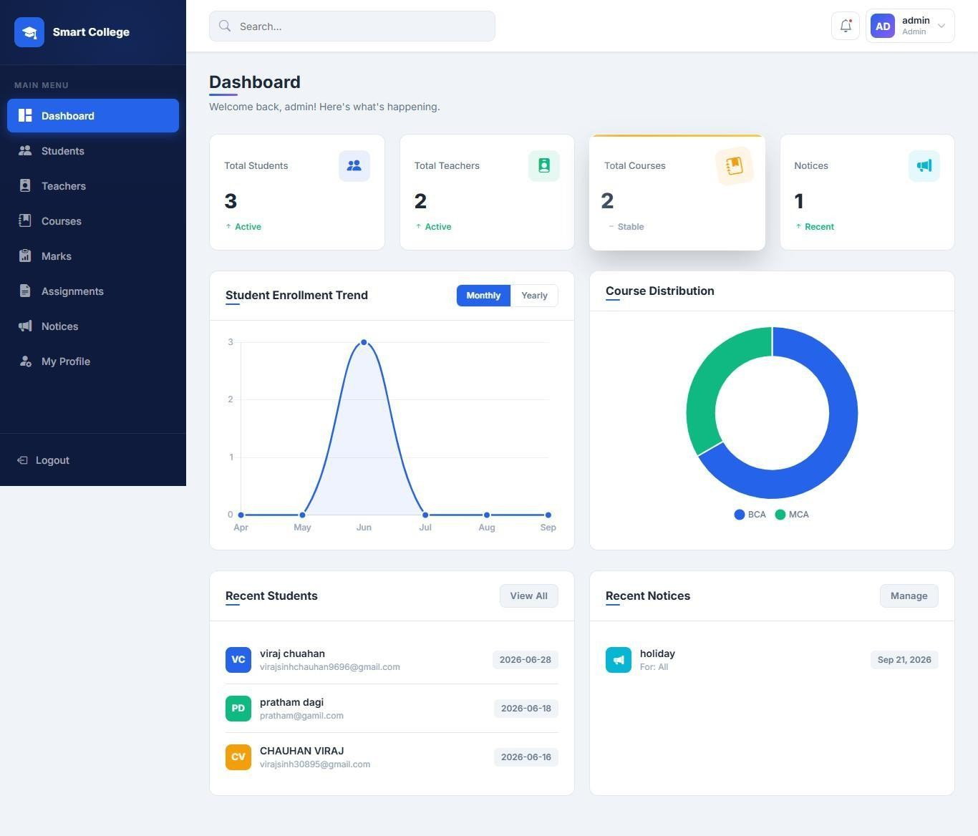
Home Page

This is the home page of admin side of website.

Students
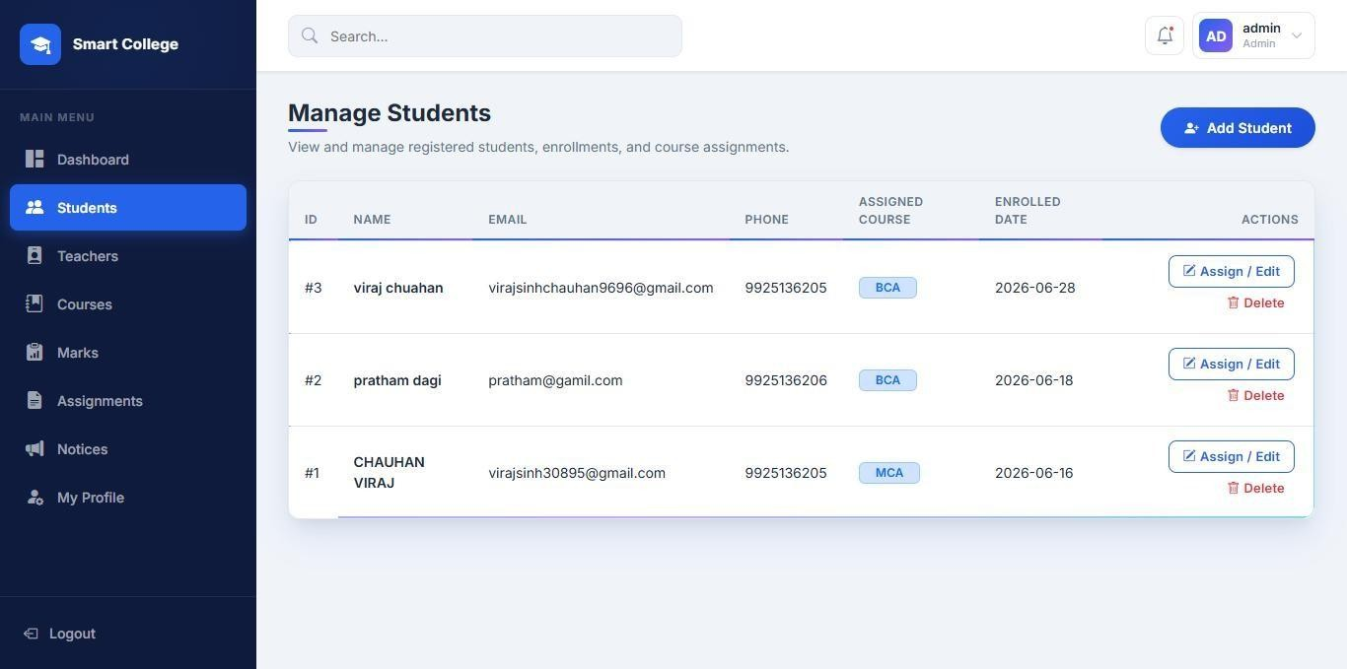

This page allows the Admin to manage student details, including enrollment, course assignment, and student records

TEACHER
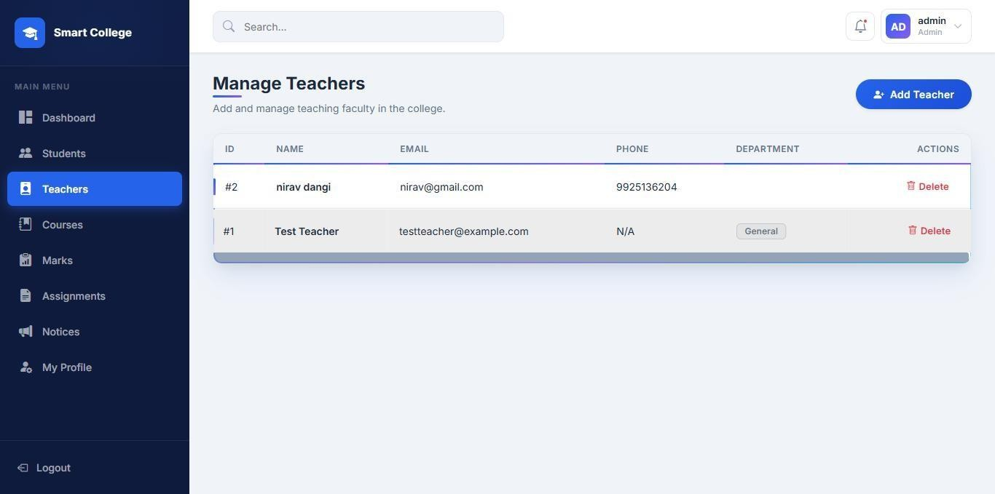

This page allows the Admin to manage teacher details, including adding, viewing, and deleting teachers.

COURSES
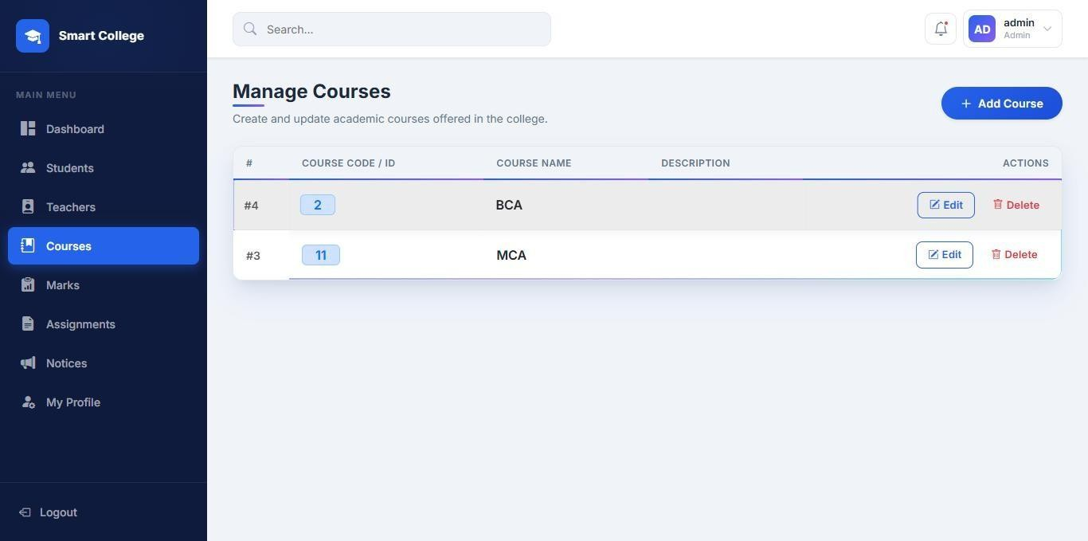

This page allows the Admin to manage courses, including adding, editing, and deleting course details.

MARKS

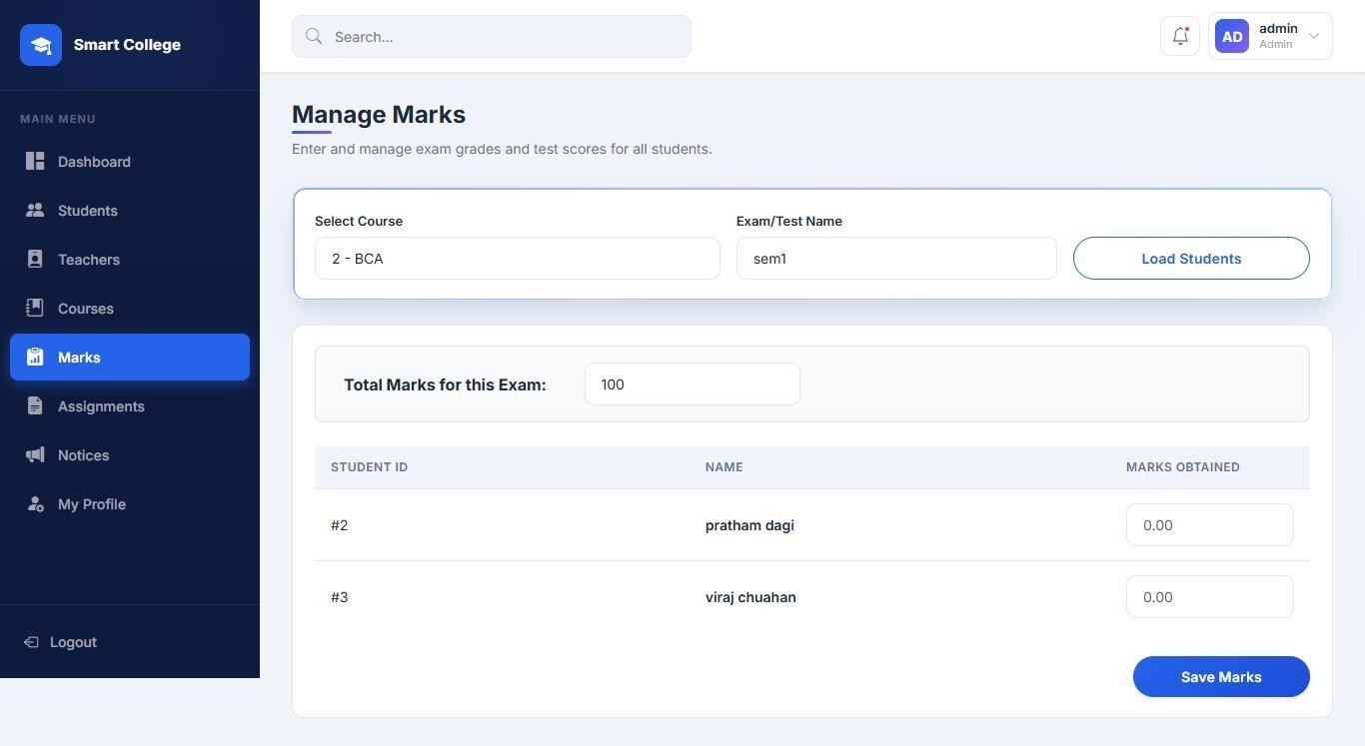

This page allows the Admin to manage student marks by selecting courses, entering marks, and saving the results.

ASSIGNMENTS
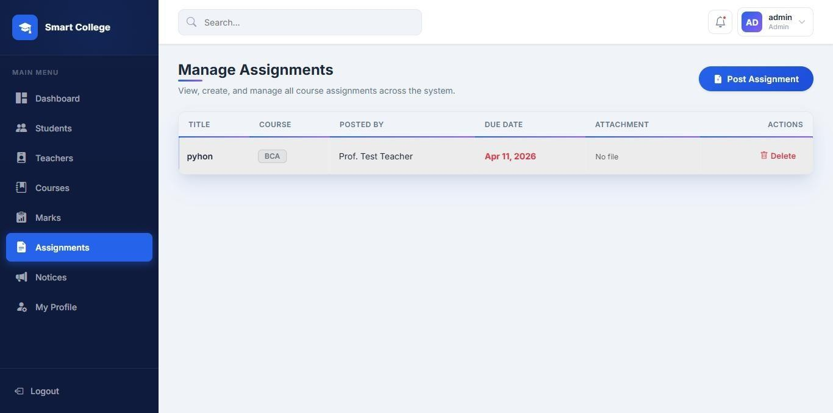

This page allows to Admin to give assignments to students

NOTICES
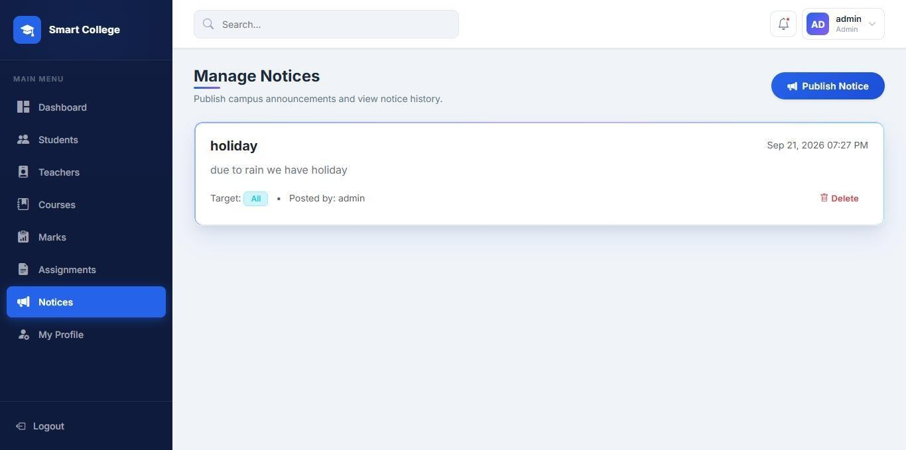

This page allows the Admin to give notices to students

MY PROFILE
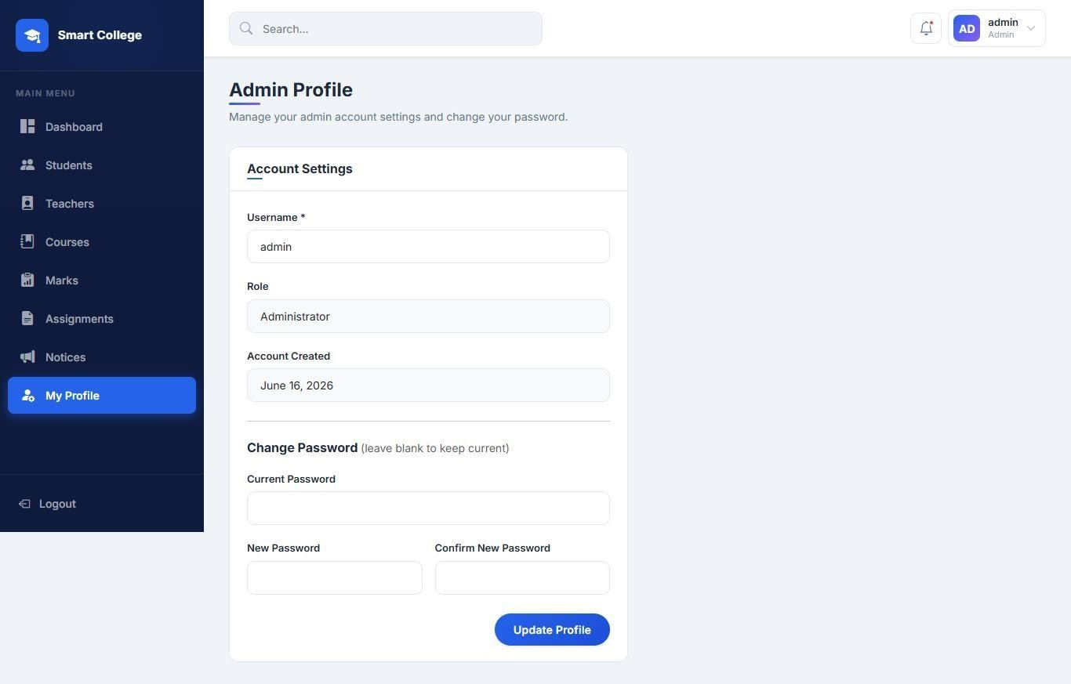

This page allows the Admin edit password and usernames

login
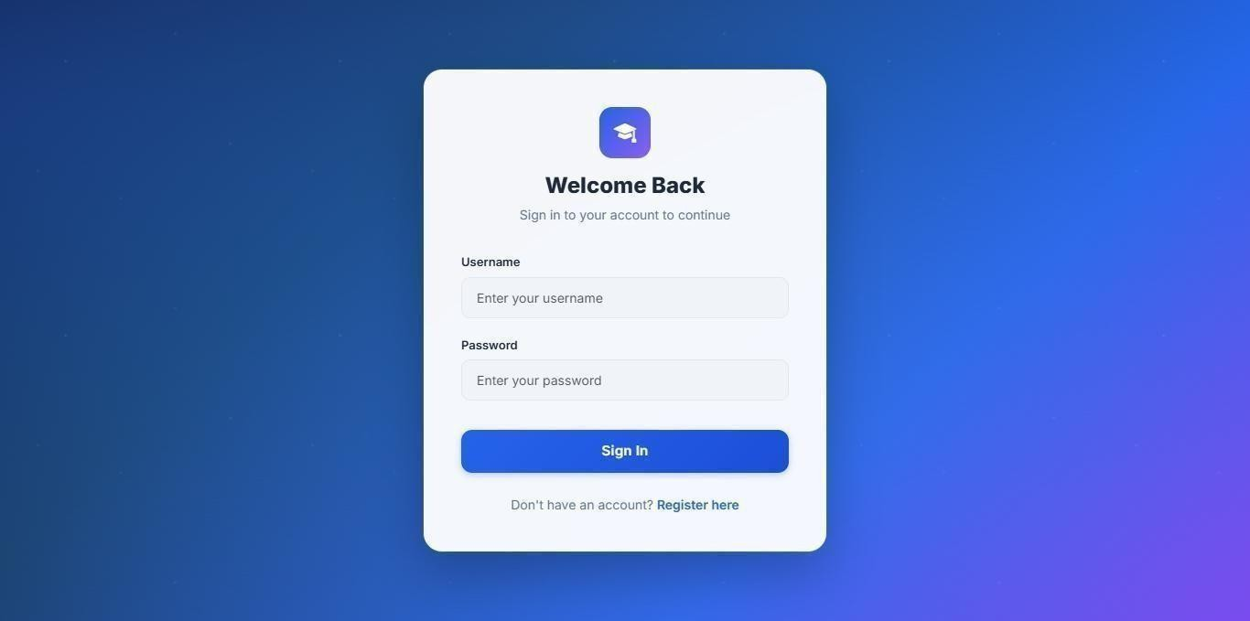

This page allows users and admin log in to the system by entering their username and password.

0 Landing page
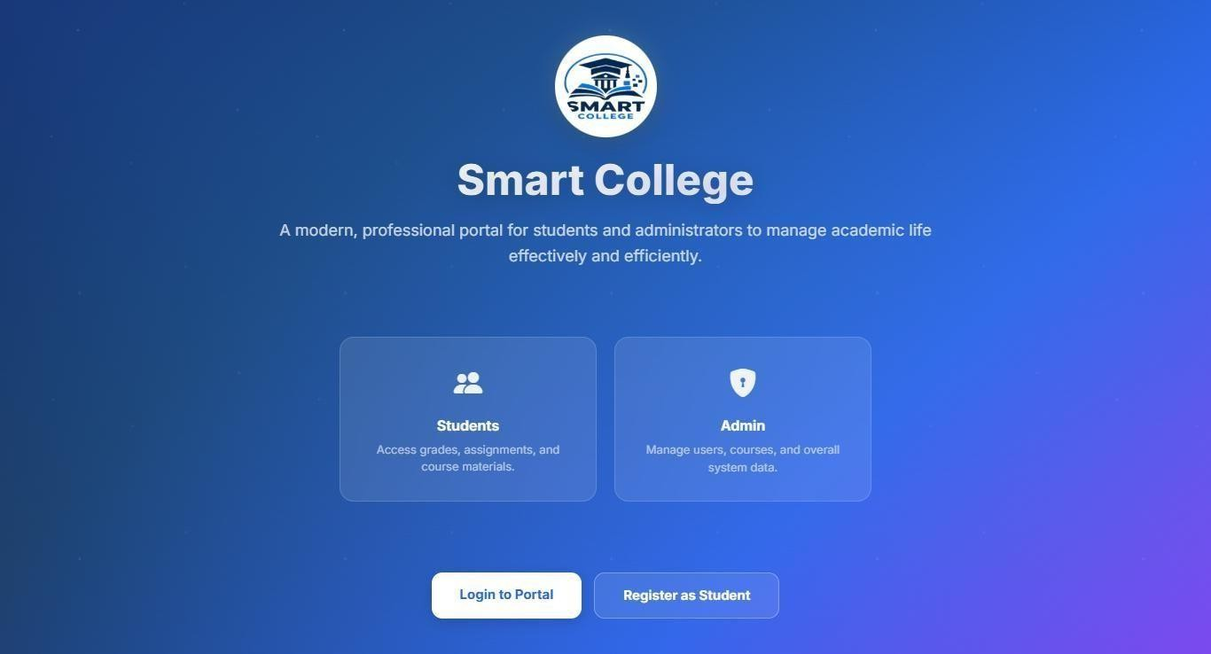

allow to login or register as student

Visitor side:
  - home page
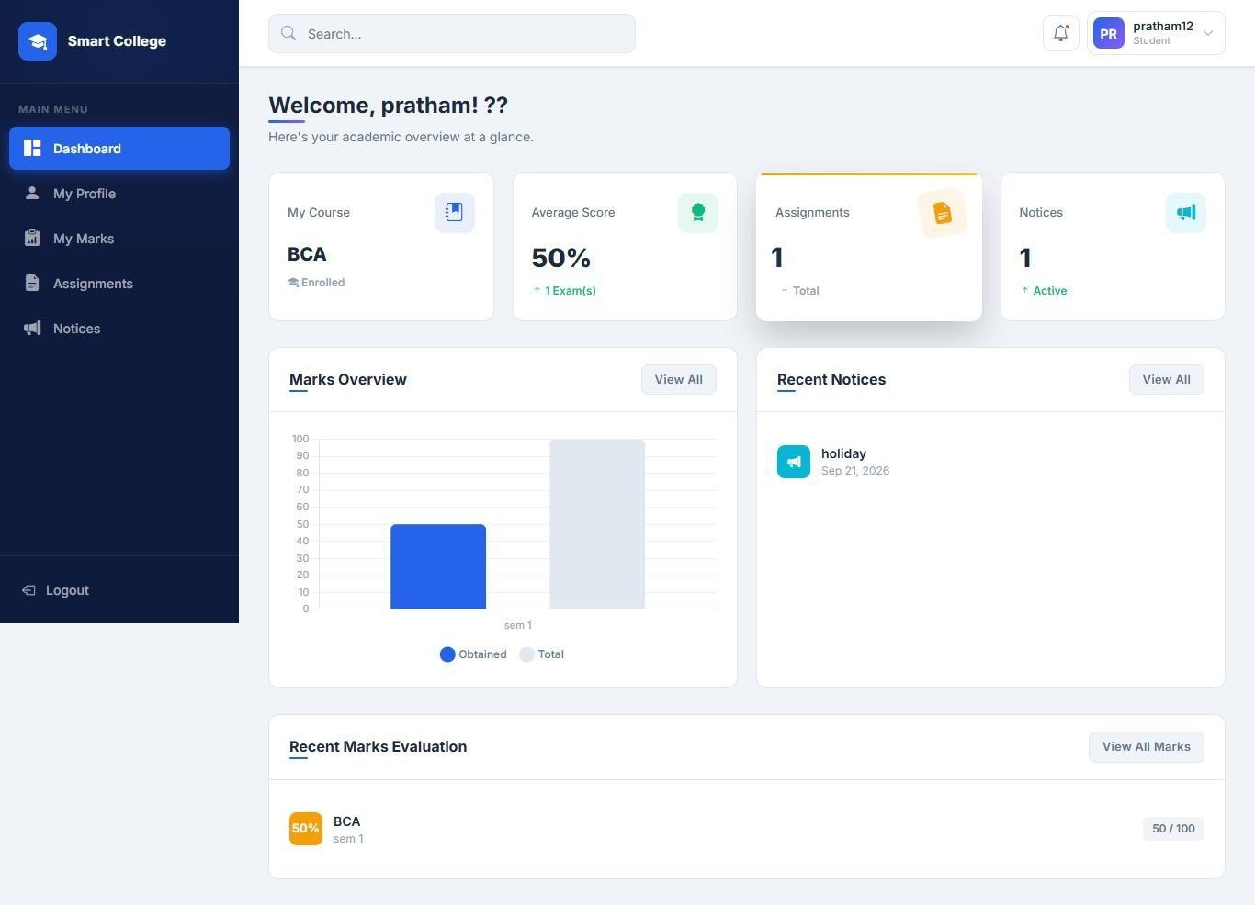

This is the home page of visitor side of website.

My profile
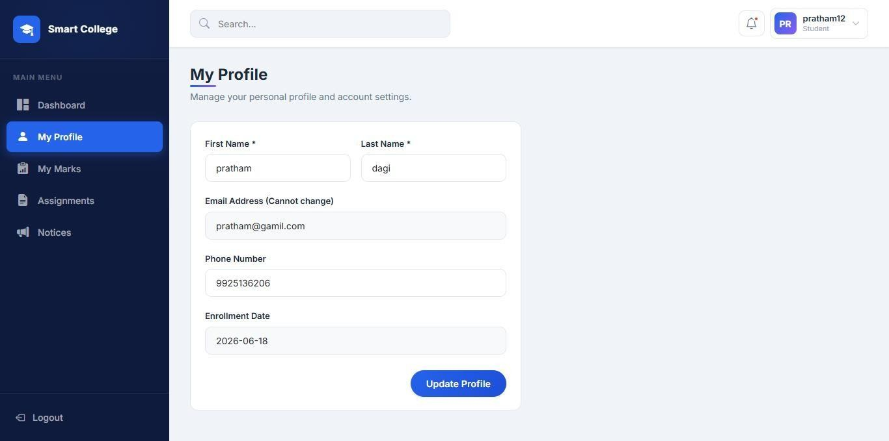

This is page allow to see and change the visitor (students) profile

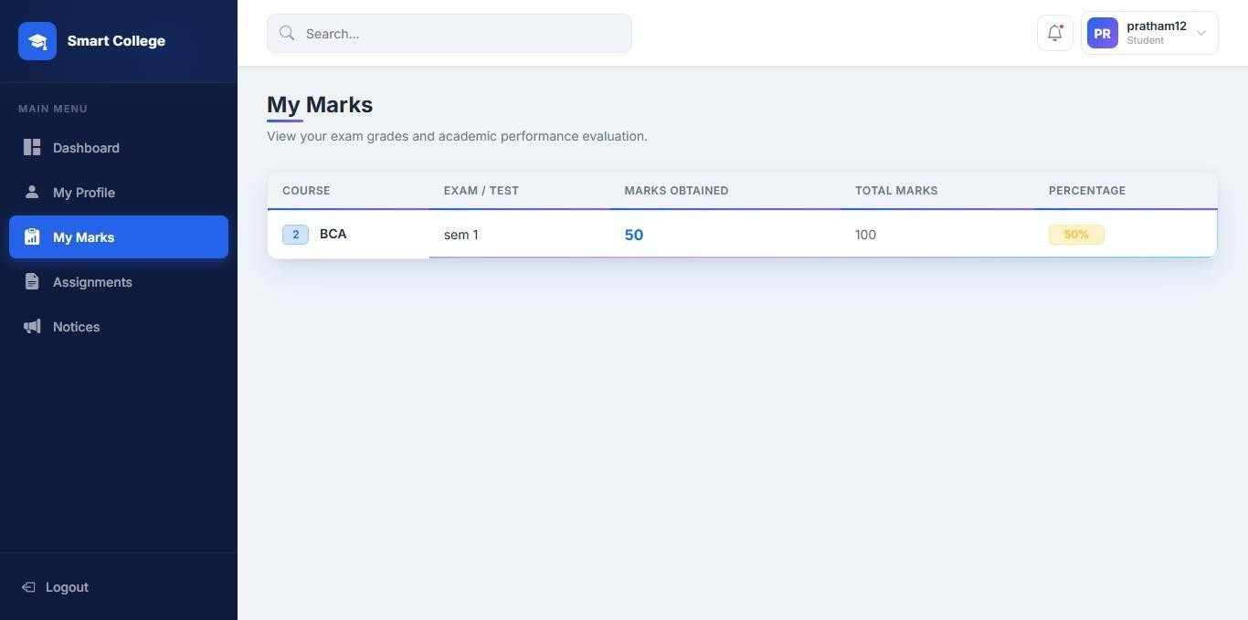
My marks

This page allow to see students their marks

Assignments
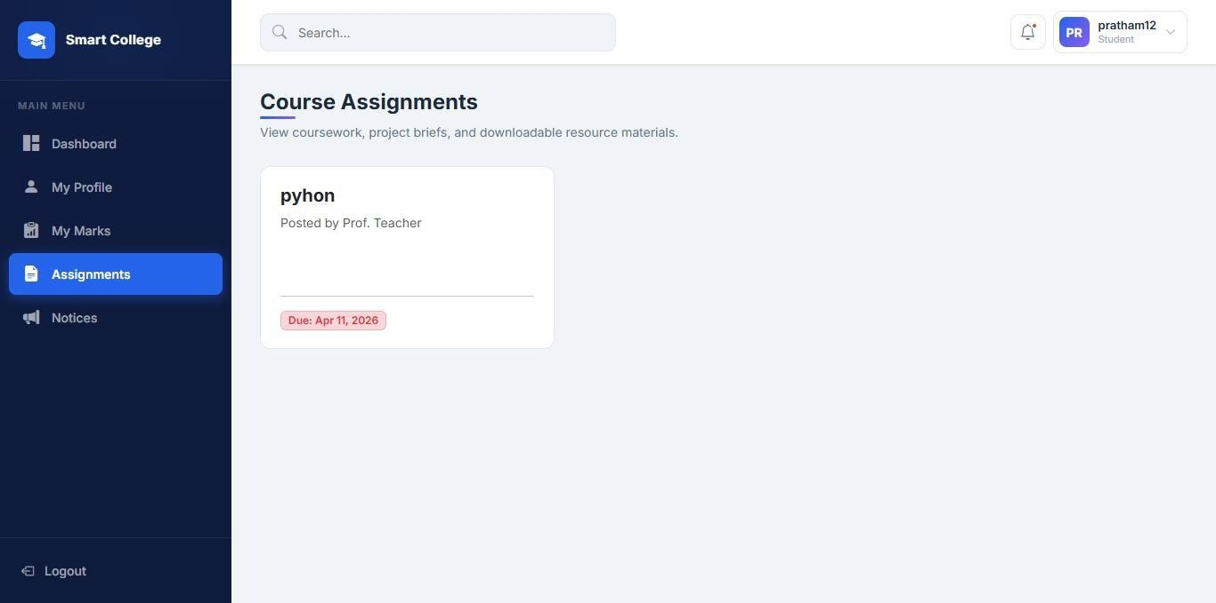

This page allow students to see their assignments

Notices
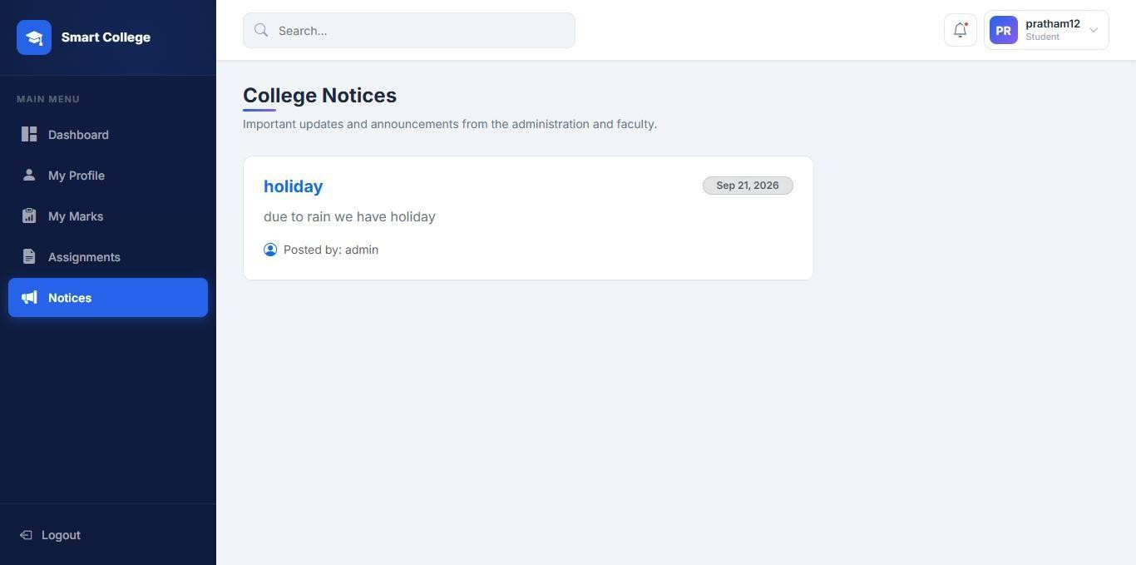

This page allow students to see notices

TESTING
Site testing is a basic component of site quality confirmation and addresses a definitive survey of determination, plan, and coding. Testing addresses a fascinating irregularity for the Site. The testing stage includes testing of the framework utilizing different test information. Planning of test information assumes a crucial part in framework testing. Subsequent to setting up the test information, the framework under review is tried utilizing those test information. In the event that testing is led effectively, it uncovers the mistakes in the Site. Also, testing exhibits that Site capabilities seem, by all accounts, to be working as per particular and execution necessities seem to have been met. Likewise information gathered as testing is led gives a decent sign of Site dependability and some sign of Site quality all in all.
The improvement of the Site frameworks includes a progression of creation exercises where valuable open doors for infusion of human questionability are gigantic. Mistakes might start to happen at very commencement of the cycle where the goals might be wrongly or defectively determined as well as in later plan and advancement stages. In light of human failure to perform and speak with flawlessness, Site improvement is trailed by a quality confirmation movement.

Test Cases
In Website engineering, the most common definition of a test case is a set of conditions or variables under which a tester will determine if a requirement or use case upon an application is partially or fully satisfied. It may take many test cases to determine that a requirement is fully satisfied. In order to fully test that all the requirements of an application are met.

Login Test

Sr. No. | Test Case | Expected Results | Actual  Result
1. | Try to login with empty fields in the username and  password text  boxes | An error message is displayed: “Username is required Password is required” | Pass
2. | Enter invalid username and  password | An error message is displayed: “Invalid username or password” | Pass
3. | Click on any  feature on the website. | On clicking on any feature, check  whether the user has logged in or not. | Pass

Table 6.2: Login Test Cases

Register Test

Sr. No. | Test Case | Expected Results | Actual  Result
1. | Try to register with empty fields in the name,  gender, contact,  text boxes | An error message is displayed: | Pass
2. | Enter invalid  email, password | An error message is displayed: | Pass

Table 6.3: Register Test Cases

LIMITATIONS & FUTURE EXTENSIONS
  - LIMITATIONS:While the new system offers significant improvements over manual processes, it has certain technical and operational limitations
    - Increased Administrative Workload: Since the teacher module has been excluded, the administrator must manually enter all attendance logs and exam grades for all students, which can become time-consuming as the student body grows.
    - Local Network Dependency: In its current WAMP server deployment, the system is only accessible within the local area network (LAN) and cannot be accessed from home unless the institution hosts it on a public web server.
    - One-Way Communication: The notice board allows the administrator to broadcast updates, but it does not support a two-way messaging or ticketing system for students to reply or submit queries.
    - No Financial Integration: The application lacks a payment gateway, meaning semester fees, exam registrations, and other financial transactions cannot be processed or tracked through the portal.
    - No Offline Access: The system requires continuous connectivity to the database server; if the local server goes down, neither the administrator nor the students can access any records.
    - Simple Scheduling Capabilites: The system does not feature a timetable generator or automated schedule-conflict resolver for classrooms or examinations.

  - FUTURE EXTENSIONS:To expand the capabilities and scope of the College Management System, the following features can be integrated in future development cycles:
- Integration of a Teacher Portal: Re-introducing a dedicated teacher module will allow instructors to log in, track attendance, and submit grades directly, thereby reducing the data-entry workload on the administrator.
- Online Fee Payment System: Integrating a secure payment gateway (such as PayPal, Stripe, or Razorpay) will enable students to view fee dues and make payments directly through the portal.
- Automated SMS and Email Alerts: Incorporating email and SMS notification APIs will allow the system to send automatic updates to students regarding low attendance thresholds, exam schedules, and new notice postings.
- Two-Way Help Desk and Messaging: Implementing an internal ticketing or live chat system will allow students to submit queries, report grading errors, and communicate directly with administrators.
- Timetable and Exam Scheduler: Adding a scheduling algorithm will automate classroom allocations, class timetables, and exam schedules, displaying them dynamically on student dashboards.
- Cloud Migration and Mobile Application: Moving the application from local WAMP hosting to cloud servers (such as AWS or Google Cloud) and developing a dedicated Android/iOS mobile application will allow users to access the system anytime, anywhere.

CONCLUSION AND REFERENCES

CONCLUSION
It has been a great pleasure for us to work on this exciting and challenging project. This project proved good for us as it provided practical knowledge of not only programming in PHP application and no some extent Windows Application and MYSQL, but also about all handling procedure related with “Smart college”.
It also provides knowledge about the latest technology used in developing web enabled application and client server technology that will be great demand in future. This will provide better opportunities and guidance in future in developing projects independently.
The College Management System is a lightweight, secure web application designed to digitalize academic record-keeping and simplify communications within a college environment. Built using PHP, MySQL, and a responsive frontend styling package, the project operates on a centralized database to connect administrators and students. The application eliminates the inefficiencies of traditional paper-based methods by providing administrators with a secure portal to manage student registration, curriculum details, grades, and daily attendance logs. At the same time, it offers students a self-service portal featuring interactive data charts to monitor their academic performance, view attendance records, and receive official notices in real time

REFERENCES

Websites:
    - https://moodle.org/
    - https://www.ellucian.com/
    - https://gibbonedu.org/
    - https://openeducat.org/

